**MID TERM EXAM PBO**

**Erwan Majid/08/2I**Link Github: <https://github.com/Majid5654/Semester-3/tree/Main/JAVA%20OOP/UTS>

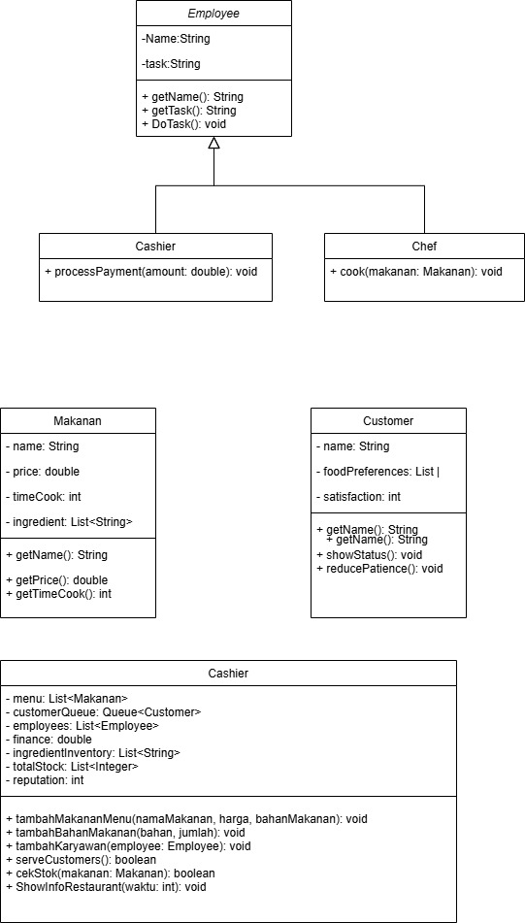Flow:  
  
  
1. Main Setup and Initialization

• In the Main class, the program starts by asking the user for input to add ingredients (Add Ingredients), add a menu item (Add Menu Item), or start a restaurant (Start Opening a Restaurant).

• These options allow the user to organize the ingredients in the inventory and add the menu items with the necessary ingredients. Once everything is ready, the restaurant simulation begins.

2. Displaying the Menu and Stock

• After the initial setup, the program displays a list of available menu items and the food stock. This gives the user an initial view of what is available in the restaurant.

3. Adding Employees

• Chef and Cashier are added as employees. Each employee has a defined task: Chef to cook and Cashier to handle payments.

4. Restaurant Service Simulation (Main Loop)

• There is a main loop that simulates the running time in a restaurant, with a maximum time of 50 units (or until stock runs out).

• At each unit of time:

o Customers Come in Randomly: There is a 30% chance that a new customer will come in. When arriving, customers will be given random names and orders based on the menu available at the restaurant.

o Serving Customers: The restaurant tries to serve customers who are in line. The service process includes:

1. Finding the Desired Menu: The program selects the menu desired by the customer and checks the availability of stock of ingredients.

2. Cooking and Validating Cooking Time: If the cooking time exceeds 5 minutes, the customer is considered impatient and leaves. If it is in accordance with the customer's patience, the stock of ingredients is reduced, and the customer is served with increased satisfaction.

3. Reducing Reputation: If the service is not satisfactory (for example, insufficient stock of ingredients or cooking time is too long), the restaurant's reputation is reduced.

4. Increasing Finances and Reputation: If the order is successful, the restaurant's finances increase based on the price of the food ordered, and the reputation increases.

5. Reducing Patience and Customer Satisfaction

• Each customer has a level of patience that decreases if they wait too long, and satisfaction that changes based on the service. If patience runs out, the customer will leave with an "angry" status.

6. Simulation Termination

• The main loop will stop if the stock of food ingredients is insufficient to serve the customer or the maximum time has been reached. The program then displays the final results of the simulation, such as the restaurant's finances and reputation.

Explanation of Classes in the Flow

• Restaurant Class: Handles restaurant operations, including adding menus and ingredients, reducing stock, managing customer queues, and adding employees.

• Customer Class: Represents customers with food preferences, patience, and satisfaction. This class provides methods for reducing patience and displaying customer status.

• Food Class: Stores food information including price, cooking time, and ingredients needed.

• Employee Class and Its Subclasses: Provides the basic structure of employees in a restaurant. The Chef class cooks food and the Cashier handles customer payments.